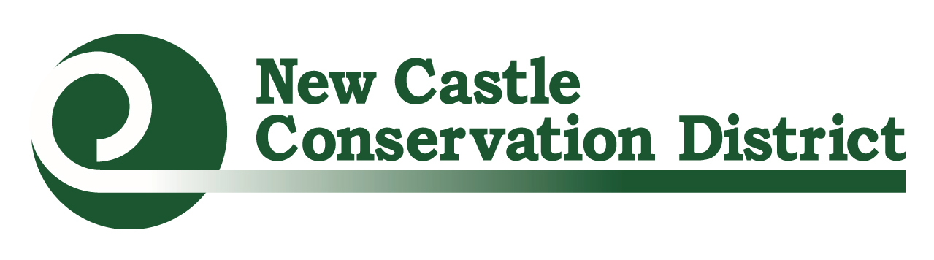Urban Farmer & Gardener Mini-Grants Application
Directions: Place cursor in blue box to complete information. Click “Tab” to proceed to next form field.

I. Organization Information:
Organization Name: Tax ID EIN:
Address: City: State: ……….... .Zip:
Contact Person: Title:
Phone: Email:
Secondary Contact Person (if applicable):
Phone: Email:
Website (if applicable):
Total Project Budget: Amount Requested (up to $2000):
Location of Project:
One to two sentence summary of project:

II. Project Information
- Describe the project to be funded. Include your projected goals, community involvement, significance, and how these grant funds will be used (1,000 characters)

- Is this a ☐existing or ☐ new project?

- If this is an existing project, please give a brief history of the project and how this funding will increase your capacity to improve access to healthy foods throughout underserved areas in NCC? (1,500 characters)

- If this is a new project, how will it improve access to healthy foods throughout underserved areas in NCC? (1,000 characters)

III. Project Sustainability
- What is the project background and experience of the individuals involved? If limited what is your action plan to learn more (500 characters)?

- How do you plan to sustain this project over time? If buying equipment or supplies for an existing project, how will these funds help to sustain your farm or garden over time? (500 characters)

- What will you do to engage your community in the project, such as youth, families, employees, neighbors, and local businesses? (500 characters)

- List all organizations (stores, other non-profits, schools, garden clubs, etc.) in the community that have previously contributed to your project.
Organization Name | Contact Person | Monetary Support | In-kind Support (volunteer time, labor) | Acquired Donations (material items)

IV. Required Attachments
☐ Letter of Support: Application must be submitted with a letter from the organization’s leader committing support to the project. Official letterhead and physical signature must be present.
☐Budget:
1. Annual budget for the project, including a general list of expenses and costs
2. Detailed expenses that you plan to use the NCCD mini-grant to cover and required match (see example in the Request for Proposal)
This is a reimbursement grant, and advances are not available. Invoices and itemized receipts must be submitted for reimbursement as per the approved financial agreement.
☐Project Photos: Email no more than 3 photos of your site to Madison.Walter@delaware.gov. Please note the following requirements:
- Save images as .jpg or .png files
- New projects should provide existing space photos
- Any photos with people in them must have a photo release form signed

V. Sign and Submit Application
Applications must be received by 4:30pm April 2, 2020. They may either be emailed to Madison.walter@delaware.gov or they can be hand delivered sent to:
New Castle Conservation District
Urban Farmer & Gardener Mini-Grant
2430 Old County Road
Newark, DE 19702

Please sign and date in the spaces provided below

Print Name

Sign Name

Date

