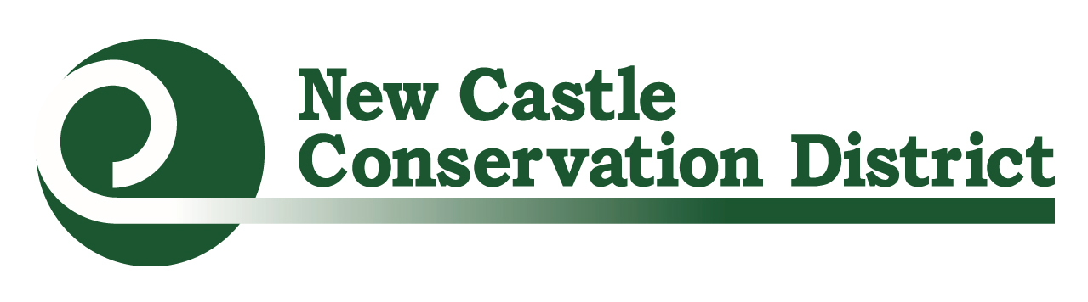Urban Farmer & Gardener Mini-Grants Application

I. Cover Sheet-Organization Information:
Organization Name Click to enter organization name. Tax ID EIN Click to enter Tax ID EIN text.
Address: Click to enter street address City: Click to enter city State: DE Zip: Click to enter zip code
Website (if applicable): Enter website URL.

Contact Person: Click to enter name. Title: Click to enter title
Phone: (123)456-789 Email: Click to enter email address

Secondary Contact Person (if applicable): Secondary Contact Information
Phone: (123)456-789 Email: Click to enter email address.

Total Project Budget: Click to enter total project budget Amount Requested (up to $2000): Click to enter amount requested
Location of Project: Click to enter project location

One to two sentence summary of project:
Click to enter your 1-2 sentence project summary

II. Project Information
Is this a ☐existing or ☐ new project?
Describe the project to be funded, including relevant project background/history, how the grant funds will be used, the community being served, and the significance (impact) the grant project will have on the local community.
Click to enter response.

How will this project improve access and/or the production of local, healthy foods throughout underserved areas in NCC?
Click to enter response.

List 1-2 goals for this Project. These goals should be the overarching changes that would like to see as a result of this project and should be realistic based on the project’s scale.
Ex. Improve access to fresh vegetables to community members living in the Mr. Rodger’s Neighborhood.
Click to enter response.

List 2-3 objectives per goal for the project. Objectives should be the tangible results of your project and should help paint a picture of what project success would look like.
Ex. Every month, through May and September, the 8th Street Community Garden leadership committee will host a workshop as part of our soil to table education series for at least 10 community members.
Ex. Build 4 additional raised beds in the community garden to grow crops for use in our food pantry during the 2021 summer season.
Click to enter response

III. Project Sustainability
What is the project background and experience of the individuals involved? If limited what is your action plan to learn more?
Click to enter response

How do you plan to sustain this project over time? If buying equipment or supplies for an existing project, how will these funds help to sustain your farm or garden over time?
Click to enter response

What will you do to engage your community in the project, such as youth, families, employees, neighbors, and local businesses?
Click to enter response

List all organizations (stores, other non-profits, schools, garden clubs, etc.) in the community that have previously contributed to your project. Include the organization name, contact person and describe their contribution.

Organization Name | Contact Person | Contribution Type (monetary, in-kind, donation) | Details/Further Information
Ex: Green Thumbs | Joe Green joegreen@gmail.com | Donation | Garden Gloves and Transplants
Ex: Star Church | Mae Rose volunteer@starchurch.com | In-Kind | Volunteer Hours during garden cleanup event
Click to enter text. | Click to enter text. | Click to enter text. | Click to enter text.
Click to enter text. | Click to enter text. | Click to enter text. | Click to enter text.
Click here to enter text. | Click here to enter text. | Click here to enter text. | Click here to enter text.
Click here to enter text. | Click here to enter text. | Click here to enter text. | Click here to enter text.
Click here to enter text. | Click here to enter text. | Click here to enter text. | Click here to enter text.
Click here to enter text. | Click here to enter text. | Click here to enter text. | Click here to enter text.
Click here to enter text. | Click here to enter text. | Click here to enter text. | Click here to enter text.
Click here to enter text. | Click here to enter text. | Click here to enter text. | Click here to enter text.
Click here to enter text. | Click here to enter text. | Click here to enter text. | Click here to enter text.
Click here to enter text. | Click here to enter text. | Click here to enter text. | Click here to enter text.

IV. Required Attachments
☐ Letter(s) of Support: Application must be submitted with a letter from the organization’s leader committing support to the project. Official letterhead and physical signature must be present.
**If project is to be completed on property not owned or leased by the applying organization an additional letter of support must be submitted by the property’s controlling organization.
☐Budget:
1. Annual budget for the project, including a general list of expenses and costs
2. Detailed expenses that you plan to use the NCCD mini-grant to cover and required match (see example in the Request for Proposal)
This is a reimbursement grant, and advances are not available. Invoices and itemized receipts must be submitted for reimbursement as per the approved financial agreement.
☐Project Photos: Email no more than 3 photos of your site to madison.walter@delaware.gov. Please note the following requirements:
- Save images as .jpg or .png files
- New projects should provide existing space photos
- Any photos with people in them must have a photo release form signed

V. Sign and Submit Application
Applications must be received by 4:30pm March 10, 2021. They may either be emailed to madison.walter@delaware.gov or they can be sent to:
New Castle Conservation District
Urban Farmer & Gardener Mini-Grant
2430 Old County Road
Newark, DE 19702

Please sign and date in the spaces provided below

Print Name

Sign Name

Date

